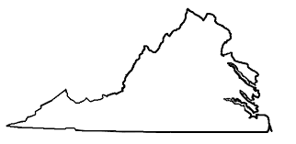

Virginia Area Al-Anon Alateen Assembly, Inc.
Area Officer Absentee Nomination Form

Summary:
This form is to be completed by any interested and qualified Virginia Area member who is interested in standing for an Area Officer’s position but is not able to attend the election Assembly either in person or virtually.

Procedure:
This form is to be completed by the VA Area member interested in standing for an Area Officer’s position and submitted to the current Area Chairperson and Area Secretary 1 week prior to the election Assembly.

Questions to be Completed:

- Candidate's name:

- District and Home Group:

- Years in Al-Anon:

- Service Experience:

- What qualities I can bring to the office:

- I certify that I am an active Al-Anon member in the Virginia Area:

- I certify that I am not an Al-Anon member who is also an AA member:

